Hong Xiang Wang
CS 470
Project 02

How to Compile:
Server: gcc -pthread -o server server.c
Client: gcc -o client client.c

How to Run:

Server:
General Format: ./server [-function] [func1] [func2].. [-s] [serv1] [serv2]...
[-function] is optional, if it's not used, then all functions in the code will be loaded.
[-s] is followed by a list of servers to connect to.

A port number will be randomly given.
A prompt will appear for the busy percentage, which determines how often the server will be busy.

Here is a screen shot example:
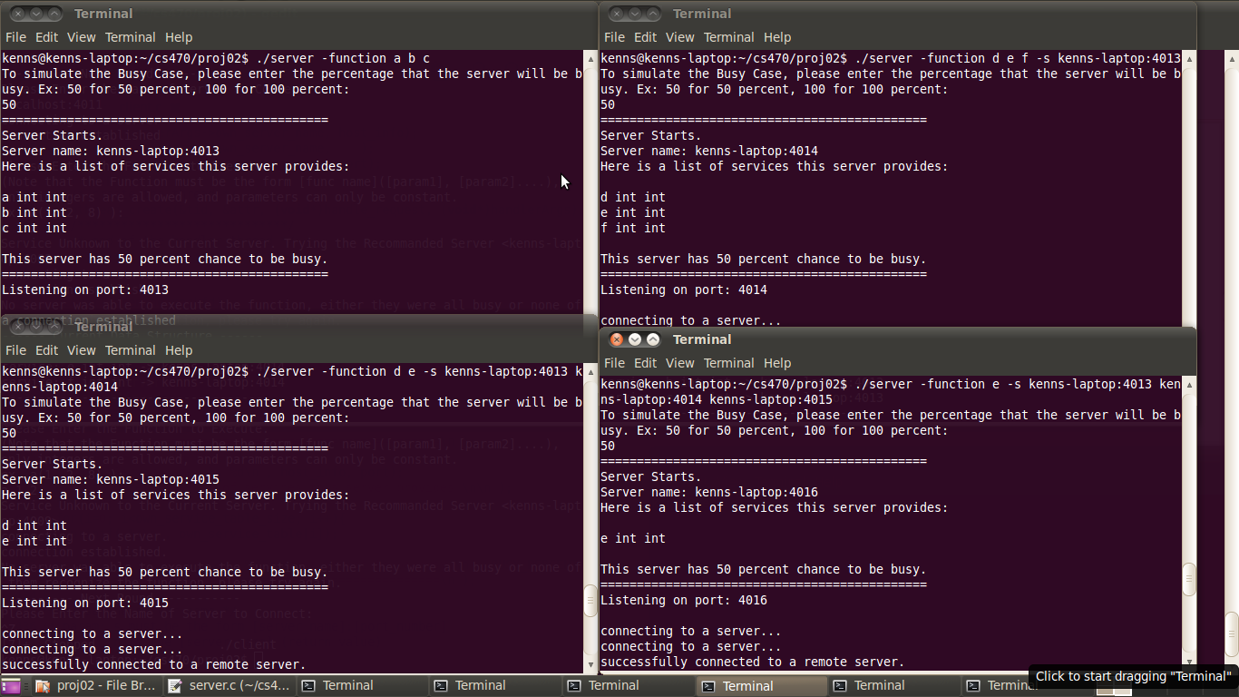
This is the name of the Server
Server name must match

Client:
Picture says all. All parameters of the functions must be INTEGER.
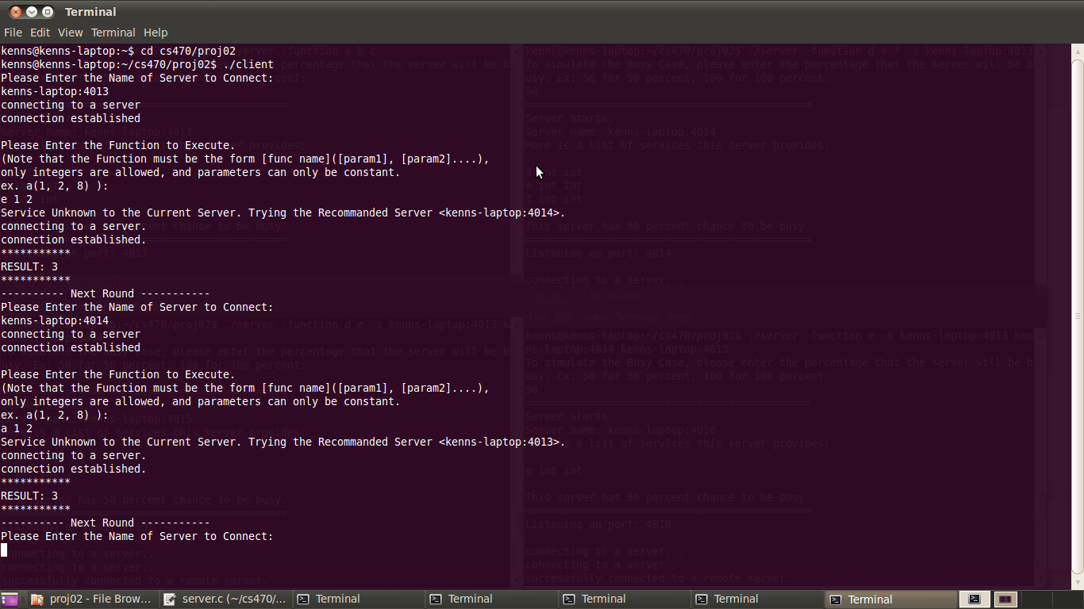
When the current server doesn't have the function the client requested, it will send a recommended server to the client.

Data Structure:

The server will maintain a 2D linked list, which stores the information of all the OTHER servers. Every time a new server enters the system, it will communicate with all other servers to update the data structure.
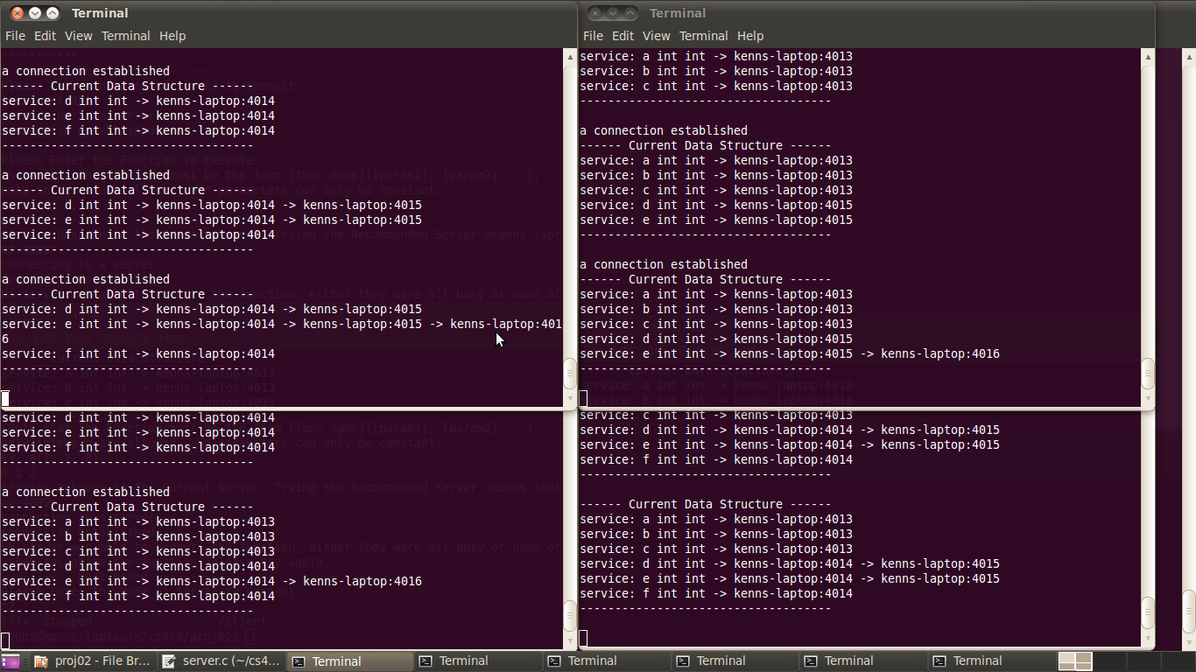
The last one of each server is the most updated data structure.
The server will also maintain a service table for itself, which contains the functions it has in itself.

The client maintains a list of all the servers it has connected, and it will send the list when connected to a server. The server then will compare the linked list to the client server list, to determine whether the client has visited all other servers which contains the servers. (Thus the ordering of the linked list doesn't matter)

If the client did visited all the servers, and no result is given, the server will send a message indicate either all servers were busy or no server recognize the function.

Here is what happens when all busy percentage is set to 100.
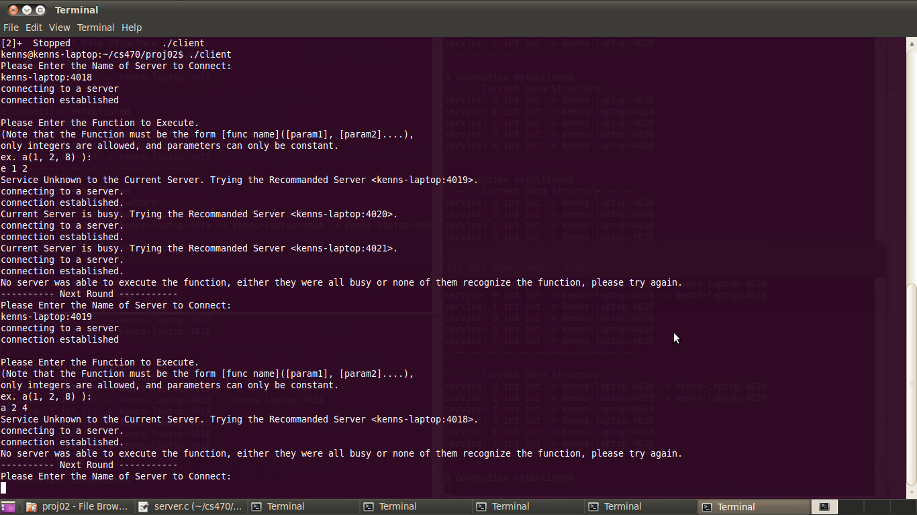

Protocols:

Examples:

/* sends hello msg to other servers, to update the data structure */
SERVER/HELLO
www.empty.com:4000
a int int
b int
…

/* send request to server, with a list of all the servers visited */
CLIENT/REQUEST
a 1 2
www.empty.com:4000
www.empty.com:4001
…

/* the server doesn't known the function, so a recommended server is sent to the client */
SERVER/UNKNOWN
e int int
www.empty.com:4001

/* the server is busy, so a recommended server is sent to the client */
SERVER/BUSY
e int int
www.empty.com:4001

/* the client has visited all the others servers and no result given */
/* so server sends the message back to the client */
SERVER/OUT

/* the server has the function, but the number of parameters doesn't match */
/* so a correct format is sent back to the client */
SERVER/MISMATCH
a int int

/* The function successfully executes, so the server sends result back to client */
SERVER/RESULT
a int int
7

